Project Plan

Work Breakdown Structure (WBS)
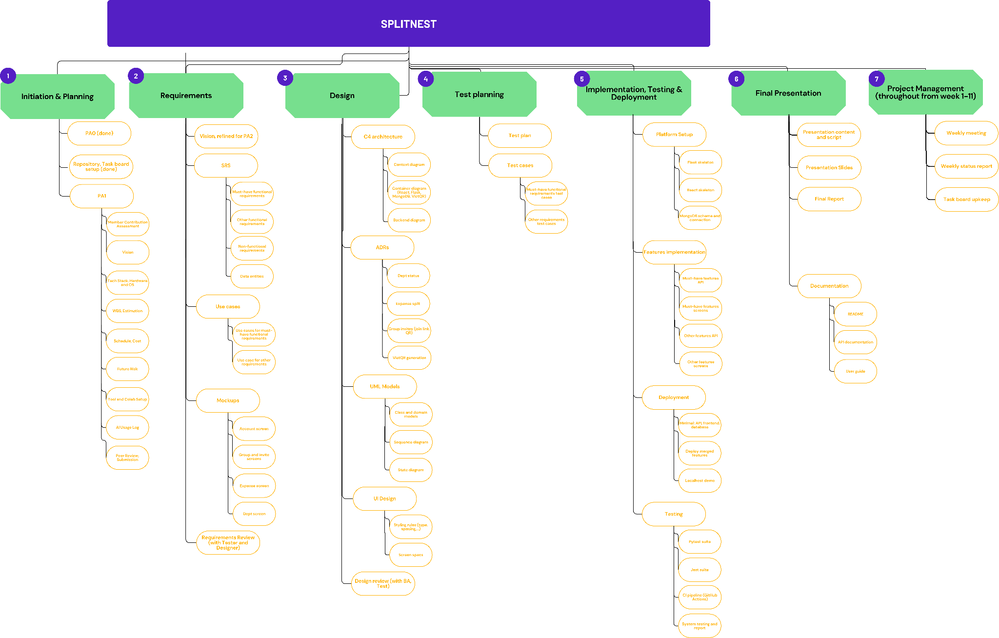

Estimation
WBS ID | Work package | Owner | Effort (person-hours) | Method / assumptions
1.1 | PA0 idea and team contract | Team | 0 | Done
1.2 | Repository and task board setup | Lại Phan Nhật Nam | 0 | Done
1.3 | PA1 document | - | - | Sum of 1.3.1 to 1.3.9
1.3.1 | Member contribution assessment | Lại Phan Nhật Nam | 1 | 3-point estimate. O=1, M=1, P=1 → E=1
1.3.2 | Vision (section 2) | Phạm Hoàng Khôi Nguyên | 4 | 3-point estimate. O=2, M=4, P=6 → E=4
1.3.3 | Tech stack, hardware and OS (section 3) | Trần Văn Nam | 4 | 3-point estimate. O=2, M=4, P=6 → E=4
1.3.4 | WBS and estimation (sections 4.2, 4.3) | Nguyễn Hoàng Tiến | 4 | 3-point estimate. O=2, M=4, P=6 → E=4
1.3.5 | Schedule and cost (sections 4.4, 4.6) | Lại Phan Nhật Nam | 6 | 3-point estimate. O=4, M=6, P=8 → E=6. Depends on 1.3.4
1.3.6 | Risk management (section 5) | Ngô Phúc Khang | 3 | 3-point estimate. O=1, M=3, P=5 → E=3
1.3.7 | Tools and collaboration setup (section 6) | Lại Phan Nhật Nam | 2 | 3-point estimate. O=1, M=2, P=3 → E=2
1.3.8 | AI usage log (section 7) | Trần Văn Nam | 1 | 3-point estimate. O=1, M=1, P=1 → E=1
1.3.9 | Peer review and submission | Lại Phan Nhật Nam | 2 | 3-point estimate. O=1, M=2, P=3 → E=2.
2.1 | Vision, refined for PA2 | Phạm Hoàng Khôi Nguyên | 4 | 3-point estimate. O=2, M=4, P=6 → E=4.
2.2 | SRS | - | - | Sum of 2.2.1 to 2.2.4
2.2.1 | Must-have functional requirements | Phạm Hoàng Khôi Nguyên | 6 | 3-point estimate. O=4, M=6, P=8 → E=6.
2.2.2 | Other functional requirements | Phạm Hoàng Khôi Nguyên | 4 | 3-point estimate. O=2, M=4, P=6 → E=4.
2.2.3 | Non-functional requirements | Phạm Hoàng Khôi Nguyên | 3 | 3-point estimate. O=1, M=3, P=5 → E=3.
2.2.4 | Data entities | Phạm Hoàng Khôi Nguyên | 4 | 3-point estimate. O=2, M=4, P=6 → E=4.
2.3 | Use cases | - | - | Sum of 2.3.1 and 2.3.2
2.3.1 | Use cases for must-have requirements | Phạm Hoàng Khôi Nguyên | 4 | 3-point estimate. O=2, M=4, P=6 → E=4.
2.3.2 | Use cases for other requirements | Phạm Hoàng Khôi Nguyên | 2 | 3-point estimate. O=1, M=2, P=3 → E=2
2.4 | Mockups | - | - | Sum of 2.4.1 to 2.4.4
2.4.1 | Account screen | Trần Văn Nam | 4 | 3-point estimate. O=2, M=4, P=6 → E=4
2.4.2 | Group and invite screens | Trần Văn Nam | 6 | 3-point estimate. O=4, M=6, P=8 → E=6. Includes QR join
2.4.3 | Expense screen | Trần Văn Nam | 6 | 3-point estimate. O=4, M=6, P=8 → E=6
2.4.4 | Debt screen | Trần Văn Nam | 4 | 3-point estimate. O=2, M=4, P=6 → E=4
2.5 | Requirements review (with Tester and Designer) | Phạm Hoàng Khôi Nguyên | 4 | 3-point estimate. O=2, M=4, P=6 → E=4.
3.1 | C4 architecture | - | - | Sum of 3.1.1 to 3.1.3
3.1.1 | Context diagram | Trần Văn Nam | 3 | 3-point estimate. O=2, M=3, P=4 → E=3
3.1.2 | Container diagram (React, Flask, MongoDB, VietQR) | Trần Văn Nam | 4 | 3-point estimate. O=2, M=4, P=6 → E=4
3.1.3 | Backend diagram | Nguyễn Hoàng Tiến | 4 | 3-point estimate. O=2, M=4, P=6 → E=4
3.2 | ADRs | - | - | Sum of 3.2.1 to 3.2.4
3.2.1 | Debt status | Nguyễn Hoàng Tiến | 3 | 3-point estimate. O=2, M=3, P=4 → E=3
3.2.2 | Expense split | Nguyễn Hoàng Tiến | 5 | 3-point estimate. O=3, M=5, P=7 → E=5.
3.2.3 | Group invites (join link, QR) | Nguyễn Hoàng Tiến | 3 | 3-point estimate. O=2, M=3, P=4 → E=3
3.2.4 | VietQR generation | Nguyễn Hoàng Tiến | 3 | 3-point estimate. O=2, M=3, P=4 → E=3
3.3 | UML models | - | - | Sum of 3.3.1 to 3.3.3
3.3.1 | Class and domain models | Trần Văn Nam | 4 | 3-point estimate. O=2, M=4, P=6 → E=4
3.3.2 | Sequence diagram | Trẩn Văn Nam | 4 | 3-point estimate. O=2, M=4, P=6 → E=4
3.3.3 | State diagram | Trần Văn Nam | 3 | 3-point estimate. O=2, M=3, P=4 → E=3.
3.4 | UI design | - | - | Sum of 3.4.1 and 3.4.2
3.4.1 | Styling rules (type, spacing, ...) | Trần Văn Nam | 3 | 3-point estimate. O=2, M=3, P=4 → E=3
3.4.2 | Screen specs | Trần Văn Nam | 3 | 3-point estimate. O=2, M=3, P=4 → E=3.
3.5 | Design review (with BA and Tester) | Trần Văn Nam | 3 | 3-point estimate. O=2, M=3, P=4 → E=3.
4.1 | Test plan | Ngô Phúc Khang | 6 | 3-point estimate. O=4, M=6, P=8 → E=6
4.2 | Test cases | - | - | Sum of 4.2.1 and 4.2.2
4.2.1 | Must-have requirements test cases | Ngô Phúc Khang | 6 | 3-point estimate. O=4, M=6, P=8 → E=6
4.2.2 | Other requirements test cases | Ngô Phúc Khang | 4 | 3-point estimate. O=2, M=4, P=6 → E=4.
5.1 | Platform setup | - | - | Sum of 5.1.1 to 5.1.3
5.1.1 | Flask skeleton | Nguyễn Hoàng Tiến | 4 | 3-point estimate. O=2, M=4, P=6 → E=4
5.1.2 | React skeleton | Trần Văn Nam | 4 | 3-point estimate. O=2, M=4, P=6 → E=4. Backup developer takes this
5.1.3 | MongoDB schema and connection | Nguyễn Hoàng Tiến | 6 | 3-point estimate. O=4, M=6, P=8 → E=6
5.2 | Features implementation | - | - | Sum of 5.2.1 to 5.2.4
5.2.1 | Must-have features API | Nguyễn Hoàng Tiến | 32 | 3-point estimate. O=24, M=32, P=40 → E=32.
5.2.2 | Must-have features screens | Trần Văn Nam | 32 | 3-point estimate. O=24, M=32, P=40 → E=32.
5.2.3 | Other features API | Nguyễn Hoàng Tiến | 16 | 3-point estimate. O=12, M=16, P=20 → E=16.
5.2.4 | Other features screens | Trần Văn Nam | 16 | 3-point estimate. O=12, M=16, P=20 → E=16
5.3 | Deployment | - | - | Sum of 5.3.1 to 5.3.3
5.3.1 | Minimal deployment: API, frontend, database | Nguyễn Hoàng Tiến | 8 | 3-point estimate. O=6, M=8, P=10 → E=8. Due week 8
5.3.2 | Deploy merged features | Nguyễn Hoàng Tiến | 6 | 3-point estimate. O=4, M=6, P=8 → E=6. Repeats for each merge, weeks 8 to 10
5.3.3 | Localhost demo fallback | Nguyễn Hoàng Tiến | 3 | 3-point estimate. O=2, M=3, P=4 → E=3. Contingency for risk R4
5.4 | Testing | - | - | Sum of 5.4.1 to 5.4.4
5.4.1 | Pytest suite | Nguyễn Hoàng Tiến | 8 | 3-point estimate. O=6, M=8, P=10 → E=8
5.4.2 | Jest suite | Ngô Phúc Khang | 8 | 3-point estimate. O=6, M=8, P=10 → E=8
5.4.3 | CI pipeline (GitHub Actions) | Ngô Phúc Khang | 5 | 3-point estimate. O=3, M=5, P=7 → E=5
5.4.4 | System testing and report | Ngô Phúc Khang | 14 | 3-point estimate. O=10, M=14, P=18 → E=14
6.1 | Presentation content and script | Lai Phan Nhật Nam | 6 | 3-point estimate. O=4, M=6, P=8 → E=6.
6.2 | Presentation slides | Phạm Hoàng Khôi Nguyên | 8 | 3-point estimate. O=6, M=8, P=10 → E=8
6.3 | Final report | Lại Phan Nhật Nam | 14 | 3-point estimate. O=10, M=14, P=18 → E=14.
6.4 | Documentation | - | - | Sum of 6.4.1 to 6.4.3
6.4.1 | README | Lại Phan Nhật Nam | 3 | 3-point estimate. O=2, M=3, P=4 → E=3
6.4.2 | API documentation | Nguyễn Hoàng Tiến | 4 | 3-point estimate. O=2, M=4, P=6 → E=4
6.4.3 | User guide | Phạm Hoàng Khôi Nguyên | 4 | 3-point estimate. O=2, M=4, P=6 → E=4
7.1 | Weekly meeting | Lại Phan Nhật Nam | 11 | 3-point estimate. per team-week O=1, M=1, P=1 → E=1 h/week × 11 weeks = 11. Team total
7.2 | Weekly status report | Lại Phan Nhật Nam | 18 | 3-point estimate. per week O=1, M=2, P=3 → E=2 h/week × 9 weeks (weeks 2 to 10) = 18
7.3 | Task board upkeep | Lại Phan Nhật Nam | 5.5 | 3-point estimate. per week O=0.5, M=0.5, P=0.5 → E=0.5 h/week × 11 weeks = 5.5

